Selecting Linked Data with Foreign Keys

When a foreign link is created in a table, QuickDRY will automatically generate code to select the item from the linked table. But, what it does not do automatically is define how the items are chosen or displayed for selection.

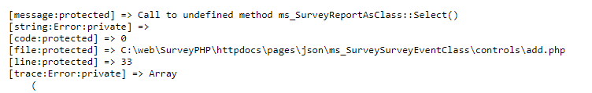

When you first include the “add” controller to a page you will see the above error because the Selection function has not been written yet.

If we go to the add controller and look at the HTML we see



And the function is highlighted yellow because it’s missing.

So, we need to go to the ms_SurveyReportAsClass and add the function.

But, before we do that, we need to pull up the table we’re selecting items from.

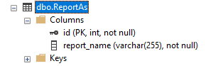

And then we can populate everything we need in the static select function

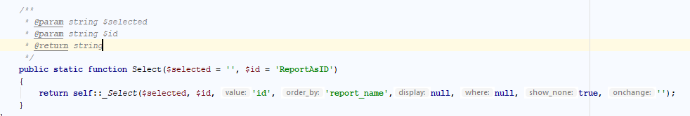

The Select function takes two parameters: the currently selected ID and the default name and ID of the form field.

Since we are not doing anything fancy, we can use the default static _Select function provided by QuickDRY.

We pass along the selected id, the id/name of the form element and then we add the column in the database table that will act as the option value and the column of the database table that will determine the order in the selection. If display is left null then the order_by will also be used as the option display.

NOTE: Display can be a “magic” property from the __get function of the class. For example, if your table has first name and last name as separate values, then you can pass in “full_name” if you have created a “full_name” magic setting which returns the last_name and first_name concatenated together.

Where allows you to use simple selectors to limit which options are shown to the user. Where is an associative array with the column and then the value. This is the same as when using the Get or GetAll static functions. When show_none is true then null is an option. When it is false, then the user must pick something. Onchange is javascript that allows you to trigger an event after the user makes a selection. This is useful for when you are using AJAX and need to populate another selection based on the first selection.



Notice that in this example the id parameter is an associative array. This allows you to use set the ID to something more specific and have the Name match the column name that the value will be stored to. On simple pages this is less necessary.

Now, when you view the control you will get your drop-down selection:

